**I2C COMMUNICATION WITH ACCELEROMETER**

The ADXL345 is a small, thin, low power, 3-axis accelerometer with high resolution (13-bit) measurement at up to ±16 g. Digital output data is formatted as 16-bit twos complement and is accessible through either a SPI (3- or 4-wire) or I2C digital interface. The ADXL345 is well suited for mobile device applications. It measures the static acceleration of gravity in tilt-sensing applications, as well as dynamic acceleration resulting from motion or shock. Its high resolution (4 mg/LSB) enables measurement of inclination changes less than 1.0°. Several special sensing functions are provided. Activity and inactivity sensing detect the presence or lack of motion and if the acceleration on any axis exceeds a user-set level. Tap sensing detects single and double taps. Free-fall sensing detects if the device is falling. These functions can be mapped to one of two interrupt output pins. An integrated, patent pending 32-level first in, first out (FIFO) buffer can be used to store data to minimize host processor intervention.

**PIN CONFIGURATION AND FUNCTION DESCRIPTION**

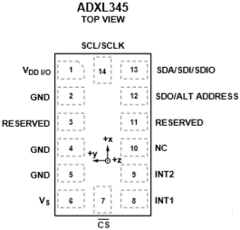

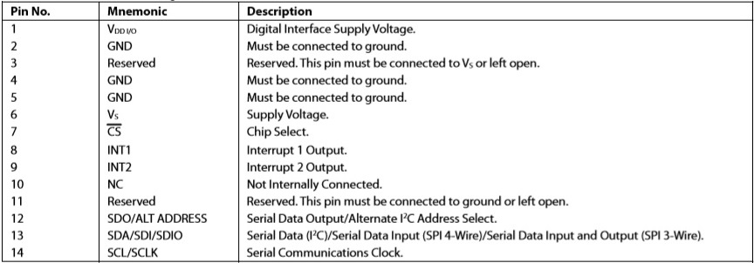

**Table: -**

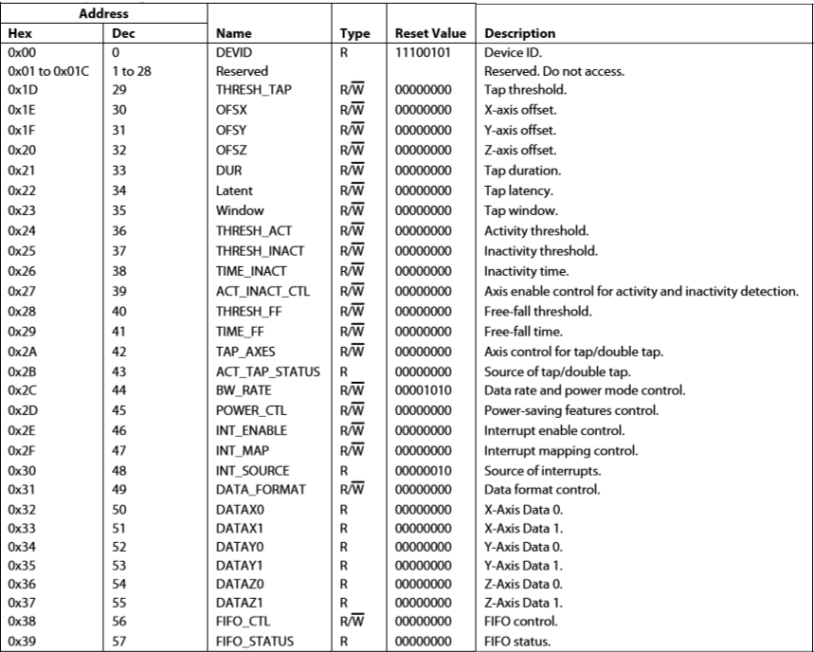

**Table: - REGISTER MAP**

**Table: - Register 0x2D—POWER_CTL (Read/Write)**

|  |  |  |  |  |  |  |  |
| --- | --- | --- | --- | --- | --- | --- | --- |
| D7 | D6 | D5 | D4 | D3 | D2 | D1 | D0 |
| 0 | 0 | LINK | AUTO_SLEEP | MEASURE | SLEEP | WAKEUP | |

**Link Bit**

Link Bit A setting of 1 in the link bit with both the activity and inactivity functions enabled delays the start of the activity function until inactivity is detected. After activity is detected, inactivity detection begins, preventing the detection of activity. This bit serially links the activity and inactivity functions. When this bit is set to 0, the inactivity and activity functions are concurrent. Additional information can be found in the Link Mode section.

When clearing the link bit, it is recommended that the part be placed into standby mode and then set back to measurement mode with a subsequent write. This is done to ensure that the device is properly biased if sleep mode is manually disabled; otherwise, the first few samples of data after the link bit is cleared may have additional noise, especially if the device was asleep when the bit was cleared.

**AUTO_SLEEP Bit**

AUTO_SLEEP Bit If the link bit is set, a setting of 1 in the AUTO_SLEEP bit sets the ADXL345 to switch to sleep mode when inactivity is detected (that is, when acceleration has been below the THRESH_INACT value for at least the time indicated by TIME_INACT). A setting of 0 disables automatic switching to sleep mode.

When clearing the AUTO_SLEEP bit, it is recommended that the part be placed into standby mode and then set back to measure- ment mode with a subsequent write. This is done to ensure that the device is properly biased if sleep mode is manually disabled; otherwise, the first few samples of data after the AUTO_SLEEP bit is cleared may have additional noise, especially if the device was asleep when the bit was cleared.

**Measure Bit**

A setting of 0 in the measure bit places the part into standby mode, and a setting of 1 places the part into measurement mode. The ADXL345 powers up in standby mode with minimum power consumption. Bits set to 1 in this register indicate that their respective functions have triggered an event, whereas a value of 0 indicates that the corresponding event has not occurred. The DATA_READY, watermark, and overrun bits are always set if the corresponding events occur, regardless of the INT_ENABLE register settings, and are cleared by reading data from the DATAX, DATAY, and DATAZ registers. The DATA_READY and watermark bits may require multiple reads, as indicated in the FIFO mode descriptions in the FIFO section. Other bits, and the corresponding interrupts, are cleared by reading the INT_SOURCE register.